**Experiment No.: 2**

**Aim**

Display future leap years from current year to a final year entered by user.

**CO1**

Understands basics of Python Programming language including input/output

functions, operators, basic and collection data types

**Procedure**

x= int(input("Enter the starting Year:"))  
y= int(input("Enter the end year:"))  
print("The Following are the Leap Years")  
for i in range(x,y):  
 if((i%400==0)or((i%100!=0)and(i%4==0))):  
 print(i)

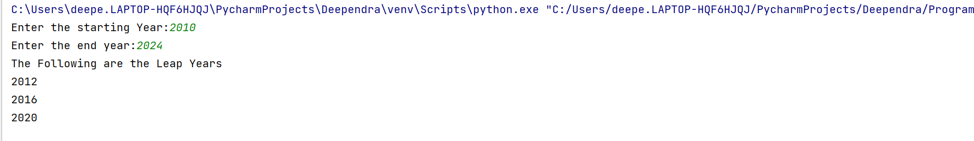**Output Screenshot**

**Result**

The program was executed and the result was successfully obtained. Thus CO1 was obtained.

**Experiment No.: 3**

**Aim**

List comprehensions:

(a) Generate positive list of numbers from a given list of integers

(b) Square of N numbers

(c) Form a list of vowels selected from a given word

**CO1**

Understands basics of Python Programming language including input/output

functions, operators, basic and collection data types

**(A)**

**Procedure**

list1=[12,34,-16,75,-44]  
print("List items are:",list1)  
print("Positive numbers are:")  
for num in list1:  
 if (num>0):  
 print(num)

**Output Screenshot**

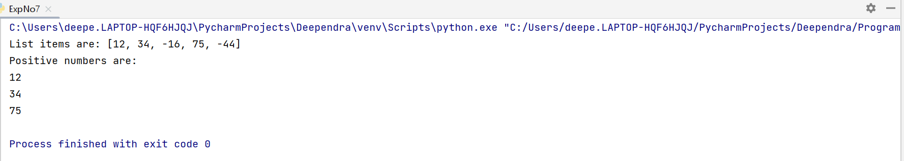

**(B)**

**Procedure**

n=int(input("Enter the Limit:"))  
squares=[i*i for i in range(0,n+1)]  
print("Squares are:",squares)

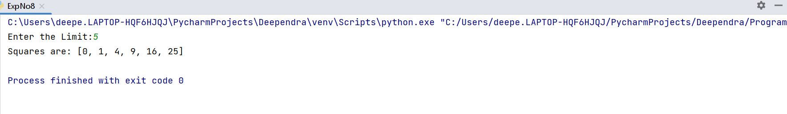**Output Screenshot**

**(C)**

**Procedure**

word=input("Enter your Word:")  
for letter in word:  
 if letter in "aeiou":  
 print(letter)

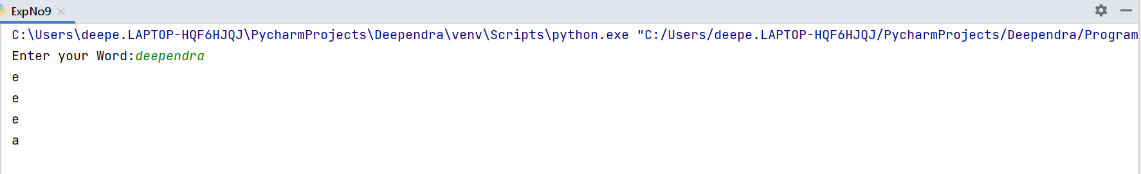**Output Screenshot**

**(D)**

**Procedure**

list1=[]

list2=["Windows","Linux"]

for item in list2:

for ele in item:

result=ord(ele)

list1.append(result)

print(list1)

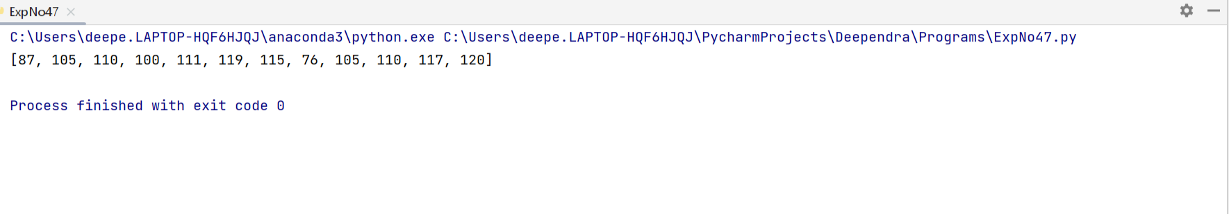**Output Screenshot**

**Result**

The program was executed and the result was successfully obtained. Thus CO1 was obtained.

**Experiment No.: 4**

**Aim**

Count the occurrences of each word in a line of text.

**CO1**

Understands basics of Python Programming language including input/output

functions, operators, basic and collection data types

**Procedure**

str=input("Enter the String:")  
counts = dict()  
str = str.split()  
  
for i in str:  
 if i in counts:  
 counts[i] += 1  
 else:  
 counts[i] = 1

print(counts)

**Output Screenshot**

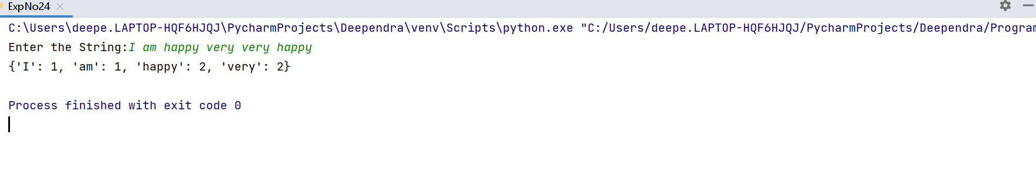

**Result**

The program was executed and the result was successfully obtained. Thus CO1 was obtained.

**Experiment No.: 5**

**Aim**

Prompt the user for a list of integers. For all values greater than 100, store ‘over’ instead.

**CO1**

Understands basics of Python Programming language including input/output

functions, operators, basic and collection data types

**Procedure**

x=int(input("Enter the list of integers:\n"))  
for i in range(0,x):  
 a=(int(input()))  
 if(a>100):  
 a="over"  
 print(a)  
 else:  
 print(a)

print(counts)

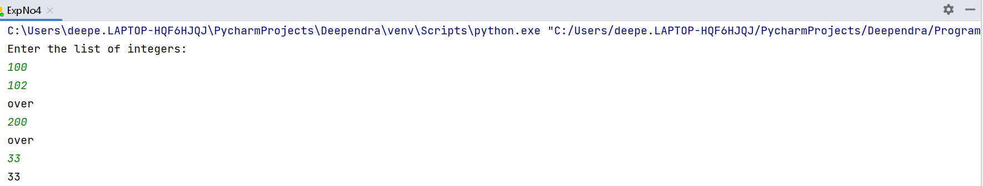**Output Screenshot**

**Result**

The program was executed and the result was successfully obtained. Thus CO1 was obtained.

**Experiment No.: 6**

**Aim**

Store a list of first names. Count the occurrences of ‘a’ within the list

**CO1**

Understands basics of Python Programming language including input/output

functions, operators, basic and collection data types

**Procedure**

a=int(input("Enter the no of strings:"))  
print("Enter the strings")  
list=[]  
count=0  
for i in range(0,a):  
 ele=input()  
 list.append(ele)  
print(list)  
for i in list:  
 for j in i:  
 if j == 'a':  
 count=count+1  
print(count)

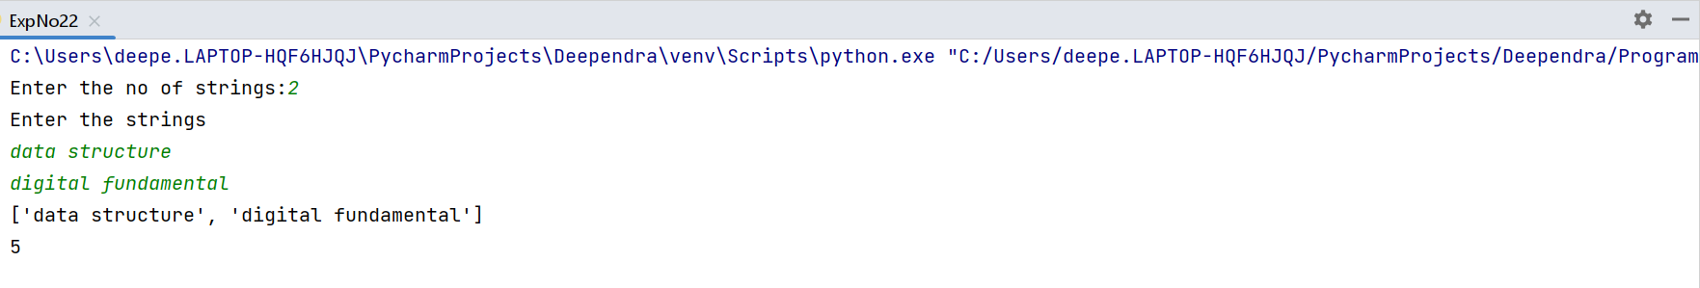**Output Screenshot**

**Result**

The program was executed and the result was successfully obtained. Thus CO1 was obtained.

**Experiment No.: 7**

**Aim**

Enter 2 lists of integers. Check (a) Whether list are of same length (b) whether list sums

to same value (c) whether any value occur in both

**CO1**

Understands basics of Python Programming language including input/output

functions, operators, basic and collection data types

**Procedure**

list1=[]  
n = int(input("Enter number of elements : "))  
print("Enter the elements:")  
for i in range(0, n):  
 i = int(input())  
 list1.append(i)  
print(list1)  
list2=[]  
k = int(input("Enter number of elements : "))  
print("Enter the elements:")  
for i in range(0, k):  
 i = int(input())  
 list2.append(i)  
print(list2)  
total=0  
final=0  
a=len(list1)  
b=len(list2)  
if(a==b):  
 print("list1 and list2 are of same length")  
  
for i in range(0, len(list1)):  
 total = total + list1[i]  
print("sum of list1 is:",total)  
  
for j in range(0,len(list2)):  
 final=final+list2[j]  
print("sum of list2 is:",final)  
z=total+final  
  
print("sum of 2 lists:",z)  
if(total==final):  
 print("list sums to the same value")  
else:  
 print("sum of both list aren't the same")  
c=list(set(list1).intersection(list2))  
print("common elements are:",c)

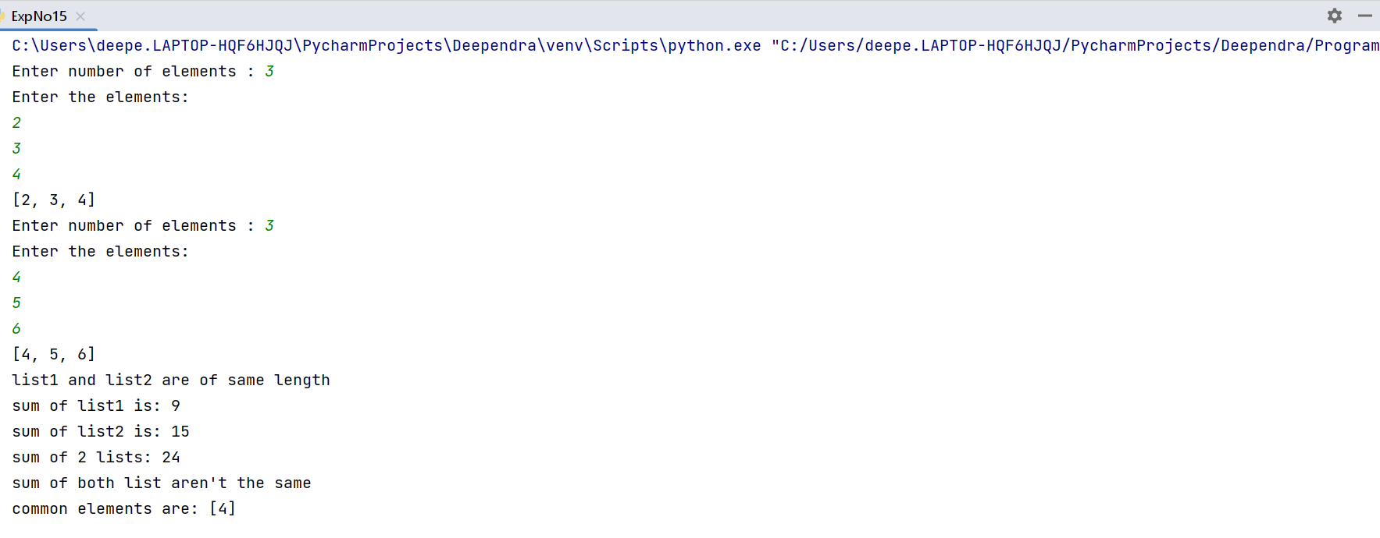**Output Screenshot**

**Result**

The program was executed and the result was successfully obtained. Thus CO1 was obtained.

**Experiment No.: 8**

**Aim**

Get a string from an input string where all occurrences of first character replaced with

‘$’, except first character.

**CO1**

Understands basics of Python Programming language including input/output

functions, operators, basic and collection data types

**Procedure**

n=input("Enter string:")  
a=n[0]  
for i in n:  
 if i==a:  
 n=n.replace(i,"$")  
 n=a+n[1:]  
print(n)

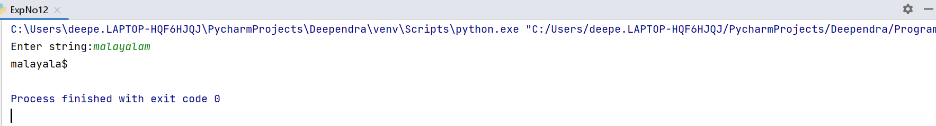**Output Screenshot**

**Result**

The program was executed and the result was successfully obtained. Thus CO1 was obtained.

**Experiment No.: 9**

**Aim**

Create a string from given string where first and last characters exchanged.

[eg: python -> nythop]

**CO1**

Understands basics of Python Programming language including input/output

functions, operators, basic and collection data types

**Procedure**

str=input("Enter the Character:")  
a=str[-1]  
b=str[0]  
c=str[1:-1]  
print(a+c+b)

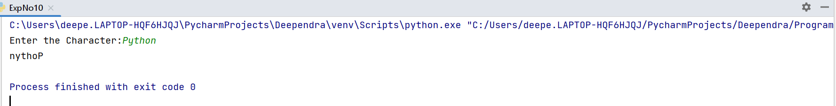**Output Screenshot**

**Result**

The program was executed and the result was successfully obtained. Thus CO1 was obtained.

**Experiment No.: 10**

**Aim**

Accept the radius from user and find area of circle.

**CO1**

Understands basics of Python Programming language including input/output

functions, operators, basic and collection data types

**Procedure**

π = 3.14  
Radius = float (input ("Enter the radius: "))  
a = π * Radius * Radius  
print ("Area of the circle:" , a)

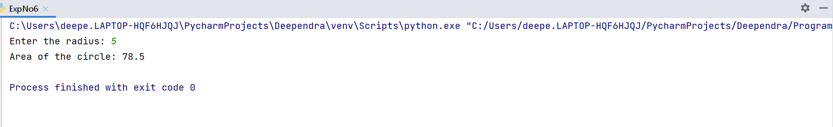**Output Screenshot**

**Result**

The program was executed and the result was successfully obtained. Thus CO1 was obtained.

**Experiment No.: 11**

**Aim**

Find biggest of 3 numbers entered.

**CO1**

Understands basics of Python Programming language including input/output

functions, operators, basic and collection data types

**Procedure**

x=int(input("Enter the First Number:"))  
y=int(input("Enter the Second Number:"))  
z=int(input("Enter the Third Number:"))  
if(x>=y)and(x>=z):  
 largest=x  
elif (y>=x)and(y>=z):  
 largest=y  
else:  
 largest=z  
  
print("Largest number is ",largest)

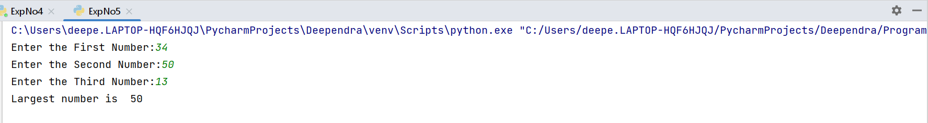**Output Screenshot**

**Result**

The program was executed and the result was successfully obtained. Thus CO1 was obtained.

**Experiment No.: 12**

**Aim**

Accept a file name from user and print extension of that.

**CO1**

Understands basics of Python Programming language including input/output

functions, operators, basic and collection data types

**Procedure**

file1=input("Enter a File Name:")  
text=file1.split('.')  
print("Extention of file",text[1])

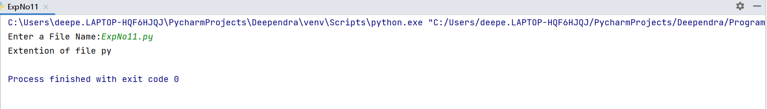**Output Screenshot**

**Result**

The program was executed and the result was successfully obtained. Thus CO1 was obtained.

**Experiment No.: 13**

**Aim**

Create a list of colors from comma-separated color names entered by user. Display

first and last colors

**CO1**

Understands basics of Python Programming language including input/output

functions, operators, basic and collection data types

**Procedure**

color=input("Enter the colors:")  
colorList=color.split(',')  
print(colorList[0])  
print(colorList[-1])

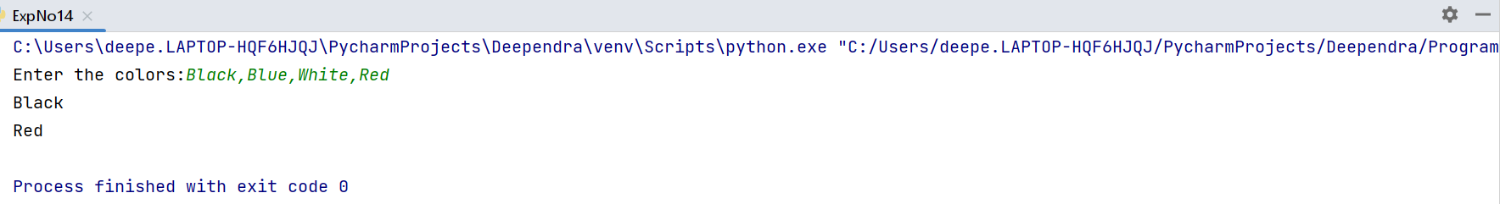**Output Screenshot**

**Result**

The program was executed and the result was successfully obtained. Thus CO1 was obtained.

**Experiment No.: 14**

**Aim**

Accept an integer n and compute n+nn+nnn.

**CO1**

Understands basics of Python Programming language including input/output

functions, operators, basic and collection data types

**Procedure**

n = int(input("Input an integer : "))  
sum = 0  
for i in range(3):  
  h = int(pow(n, i+1))  
  print(h)  
  sum = sum + h  
print("Sum :",sum)

**Output Screenshot**

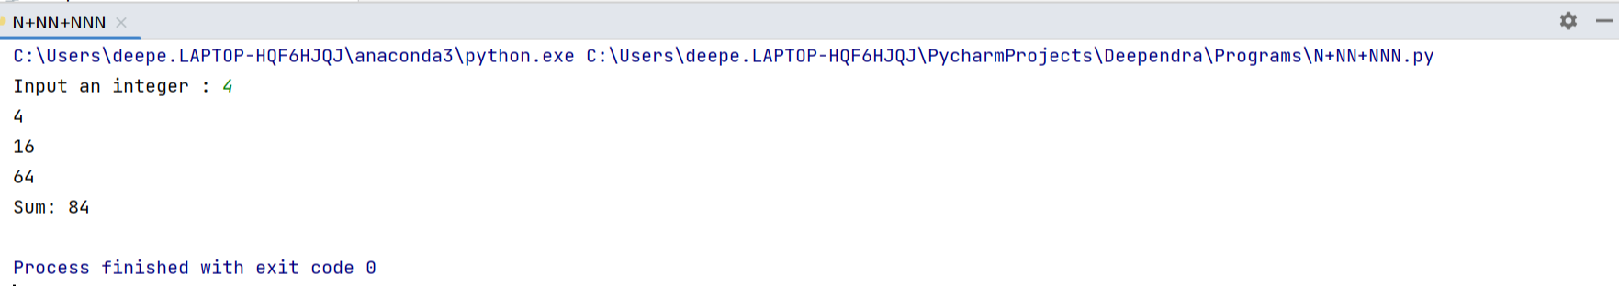

**Result**

The program was executed and the result was successfully obtained. Thus CO1 was obtained.

**Experiment No.: 15**

**Aim**

Print out all colors from color-list1 not contained in color-list2.

**CO1**

Understands basics of Python Programming language including input/output

functions, operators, basic and collection data types

**Procedure**

color_list1=input("Enter the colors in list 1 :")  
color_list2=input("Enter the colors in list 2 :")  
list1=color_list1.split()  
list2=color_list2.split()  
list3=[]  
  
print("Color List 1:",list1)  
print("Color List 2:",list2)  
  
for i in list1:  
 if i not in list2:  
 list3.append(i)  
print("Color from Color List 1 not contain in Color List 2:",list3)

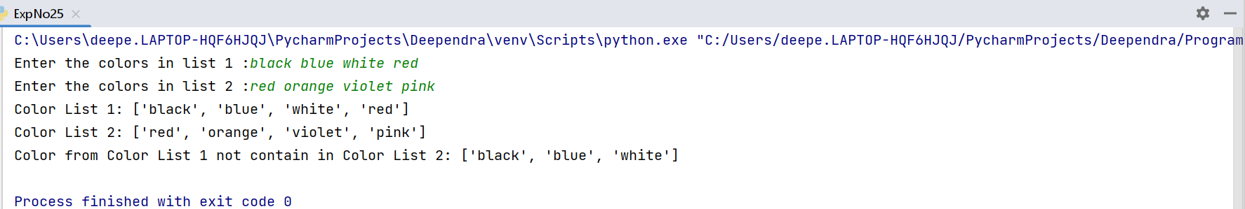**Output Screenshot**

**Result**

The program was executed and the result was successfully obtained. Thus CO1 was obtained.

**Experiment No.: 16**

**Aim**

Create a single string separated with space from two strings by swapping the

character at position 1.

**CO1**

Understands basics of Python Programming language including input/output

functions, operators, basic and collection data types

**Procedure**

str1=input("Enter first string:")  
str2=input("Enter second string:")  
a=str1[0]  
b=str2[0]  
newstr1=b+str1[1:]  
newstr2=a+str2[1:]  
print(newstr1+" "+newstr2)

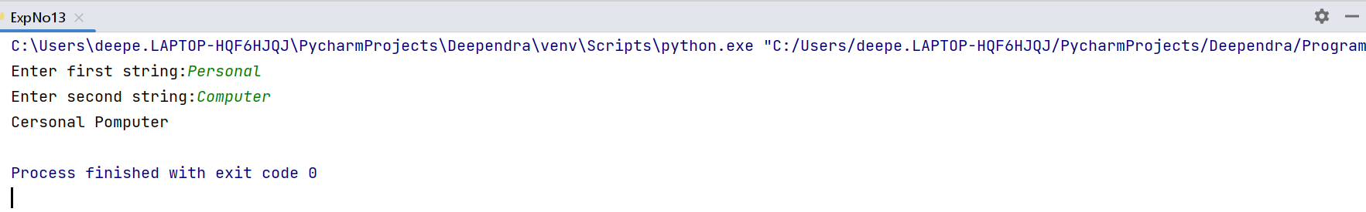**Output Screenshot**

**Result**

The program was executed and the result was successfully obtained. Thus CO1 was obtained.

**Experiment No.: 17**

**Aim**

Sort dictionary in ascending and descending order

**CO1**

Understands basics of Python Programming language including input/output

functions, operators, basic and collection data types

**Procedure**

dict1={'13':'31','12':'21'}  
sorted_a=sorted(dict1.keys())  
print(sorted_a)  
sorted_a=sorted(dict1.items())  
print(sorted_a)  
sorted_a=sorted(dict1.values())  
print(sorted_a)  
sorted_a=sorted(dict1.items(),reverse=True)  
print(sorted_a)

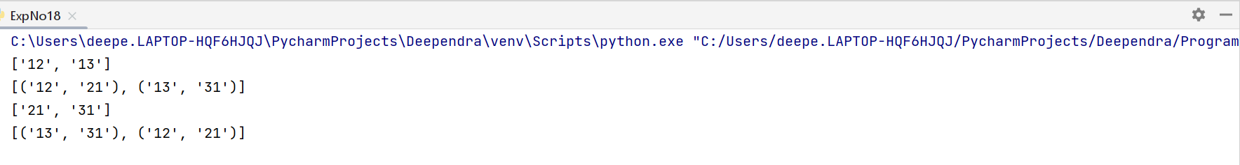**Output Screenshot**

**Result**

The program was executed and the result was successfully obtained. Thus CO1 was obtained.

**Experiment No.: 18**

**Aim**

Merge two dictionaries

**CO1**

Understands basics of Python Programming language including input/output

functions, operators, basic and collection data types

**Procedure**

d1={'fruit':'Apple','color':'Black','price in(gm)':40}  
d2={'OS':'Windows','car':'Creta','model':'tata'}  
d1.update(d2)  
print(d1)

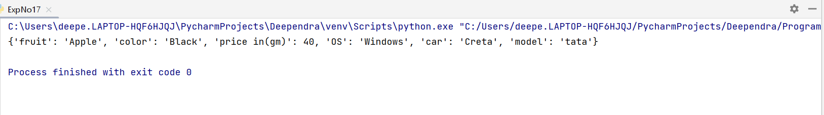**Output Screenshot**

**Result**

The program was executed and the result was successfully obtained. Thus CO1 was obtained.

**Experiment No.: 19**

**Aim**

Find gcd of 2 numbers

**CO1**

Understands basics of Python Programming language including input/output

functions, operators, basic and collection data types

**Procedure**

import math  
num1=int(input("Enter the First number:"))  
num2=int(input("Enter the Second number:"))  
  
print("GCD of " + str(num1) + " and " + str(num2) + " is:",math.gcd(num1,num2))

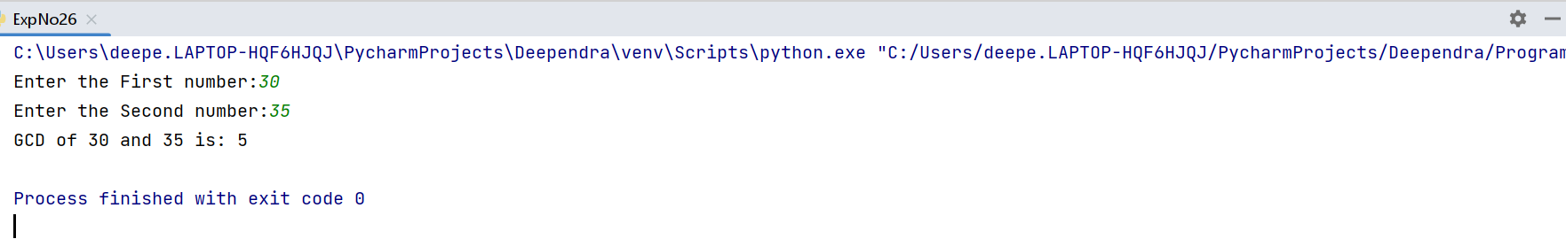**Output Screenshot**

**Result**

The program was executed and the result was successfully obtained. Thus CO1 was obtained.

**Experiment No.: 20**

**Aim**

From a list of integers, create a list removing even numbers

**CO1**

Understands basics of Python Programming language including input/output

functions, operators, basic and collection data types

**Procedure**

a=int(input("Enter the no of elements:"))  
list=[]  
  
for i in range(a) :  
 n = int(input("Enter the elements:"))  
 list.append(n)  
print("List Items",list)  
  
for i in list:  
 if(i%2==0):  
 list.remove(i)  
print("List after removing even items",list)

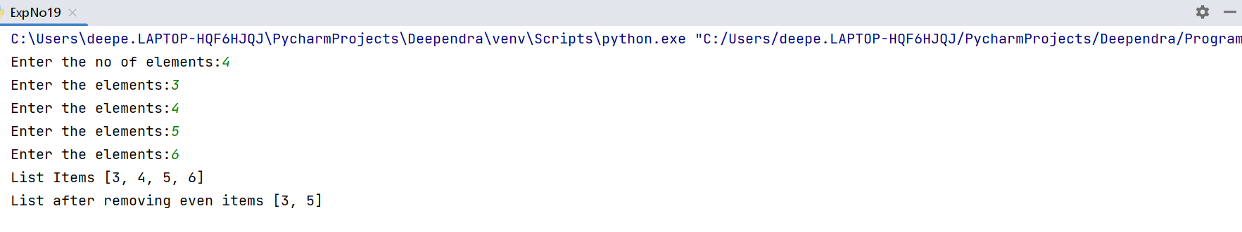**Output Screenshot**

**Result**

The program was executed and the result was successfully obtained. Thus CO1 was obtained.

**Experiment No.: 21**

**Aim**

Program to find the factorial of a number

**CO2**

Implement decision making, looping constructs and functions

**Procedure**

n=int(input("Enter a number: "))  
fact=1  
if n<0:  
 print("Factorial for negative numbers does not exist")  
elif n==0:  
 print("The factorial of 0 is 1")  
else:  
 for i in range(1,n+1):  
 fact=fact*i  
 print("The factorial is",fact)

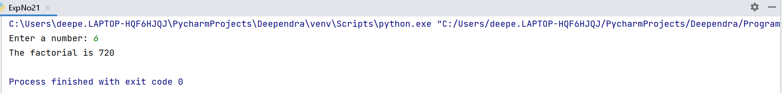**Output Screenshot**

**Result**

The program was executed and the result was successfully obtained. Thus CO1 was obtained.

**Experiment No.: 22**

**Aim**

Generate Fibonacci series of N terms

**CO2**

Implement decision making, looping constructs and functions

**Procedure**

num=int(input("Enter the no of terms:"))  
n1=0  
n2=1  
print("Fibonacci Series:", n1, n2, end=" ")  
for i in range(2, num):  
 n3 = n1 + n2  
 n1 = n2  
 n2 = n3  
 print(n3, end=" ")

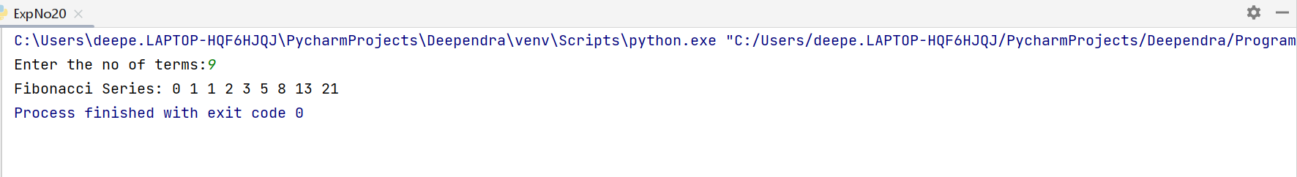**Output Screenshot**

**Result**

The program was executed and the result was successfully obtained. Thus CO1 was obtained.

**Experiment No.: 23**

**Aim**

Find the sum of all items in a list

**CO2**

Implement decision making, looping constructs and functions

**Procedure**

**Output Screenshot**

**Result**

The program was executed and the result was successfully obtained. Thus CO1 was obtained.

**Experiment No.: 24**

**Aim**

Generate a list of four digit numbers in a given range with all their digits even and the

number is a perfect square.

**CO2**

Implement decision making, looping constructs and functions

**Procedure**

a=int(input("Enter upper limit:"))  
b=int(input("Enter lower limit:"))  
lists=[]  
  
for i in range (a,b+1):  
  
 for j in range(1,i):  
 if j * j == i:  
 string=str(i)  
 if int(string[0]) % 2 == 0 and int(string[1]) % 2 == 0 and int(string[2]) % 2 == 0 and int(string[3]) % 2 == 0:  
 lists.append(string)  
print(lists)

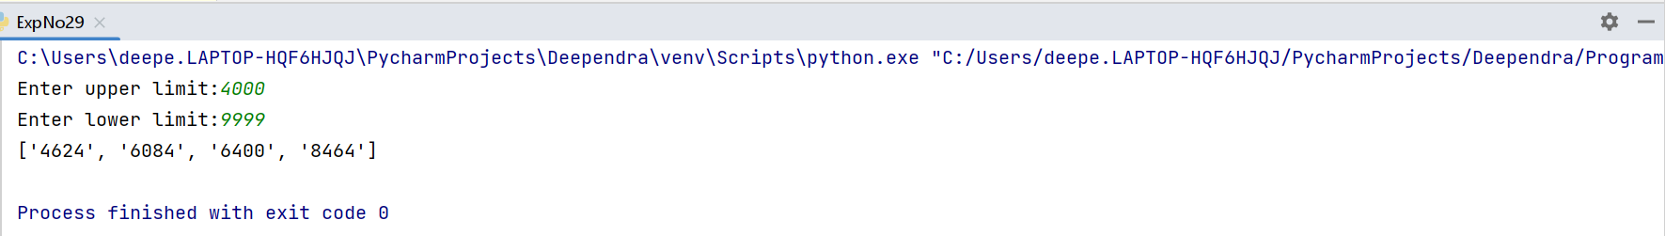**Output Screenshot**

**Result**

The program was executed and the result was successfully obtained. Thus CO1 was obtained.

**Experiment No.: 25**

**Aim**

Display the given pyramid with step number accepted from user.

Eg: N=4

1

2 4

3 6 9

4 8 12 16

**CO2**

Implement decision making, looping constructs and functions

**Procedure**

n=int(input("Enter a limit:"))  
for i in range(1,n+1):  
 for j in range(1,i+1):  
  
 print(i*j,end=" ")  
 print()

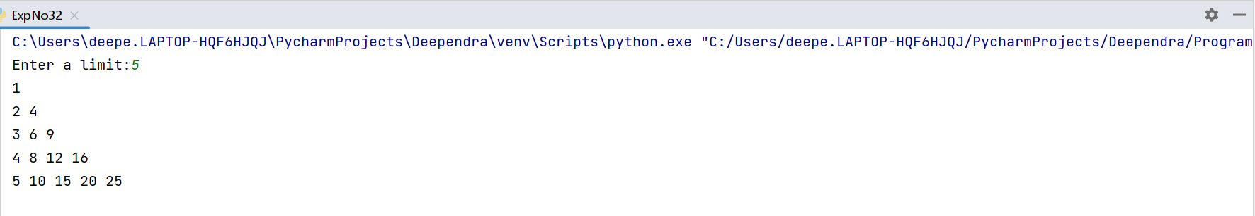**Output Screenshot**

**Result**

The program was executed and the result was successfully obtained. Thus CO1 was obtained.

**Experiment No.: 26**

**Aim**

Count the number of characters (character frequency) in a string

**CO2**

Implement decision making, looping constructs and functions

**Procedure**

str=input("Enter a string:")  
dict={}  
for i in str:  
 if i in dict:  
 dict[i]+=1  
 else:  
 dict[i]=1  
print(dict)

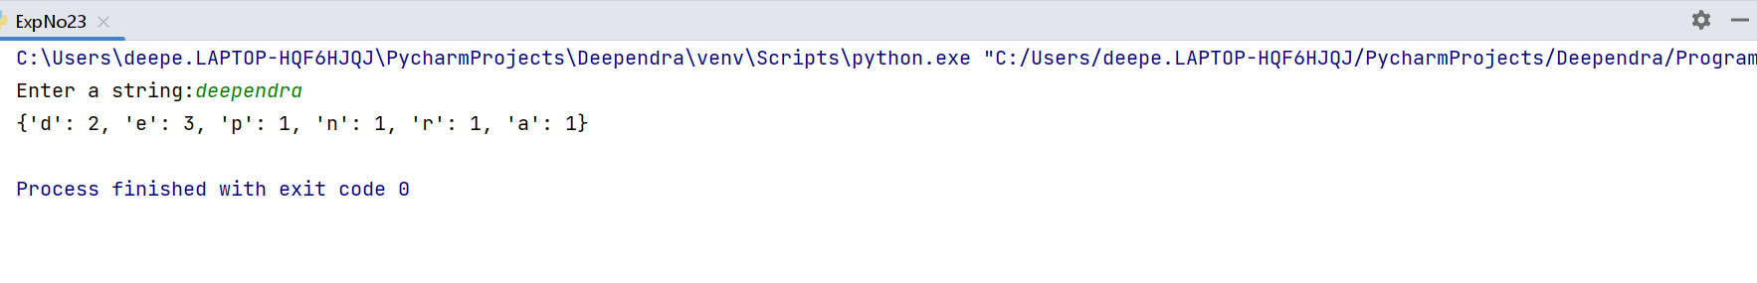**Output Screenshot**

**Result**

The program was executed and the result was successfully obtained. Thus CO1 was obtained.

**Experiment No.: 27**

**Aim**

Add ‘ing’ at the end of a given string. If it already ends with ‘ing’, then add ‘ly’

**CO2**

Implement decision making, looping constructs and functions

**Procedure**

str=input("Enter a string: ")  
if str[-3:] == 'ing':  
 print("The new string is",str + "ly")  
else:  
 print("The new string is",str + "ing")

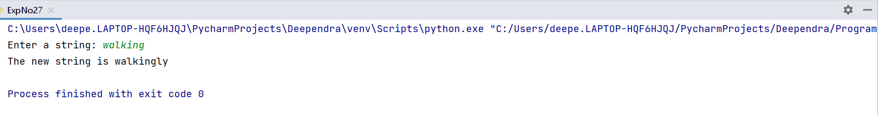**Output Screenshot**

**Result**

The program was executed and the result was successfully obtained. Thus CO1 was obtained.

**Experiment No.: 28**

**Aim**

Accept a list of words and return length of longest word

**CO2**

Implement decision making, looping constructs and functions

**Procedure**

def longestLength(a):  
 max1 = len(a[0])  
 temp = a[0]  
  
 for i in a:  
 if (len(i) > max1):  
 max1 = len(i)  
 temp = i

print("The Longest word is:", temp,  
 " and length is ", max1)  
  
a=[]  
n = int(input("Enter the no words:"))  
print("Enter the Words:")  
for j in range(0,n):  
 ele=input()  
 a.append(ele)  
longestLength(a)

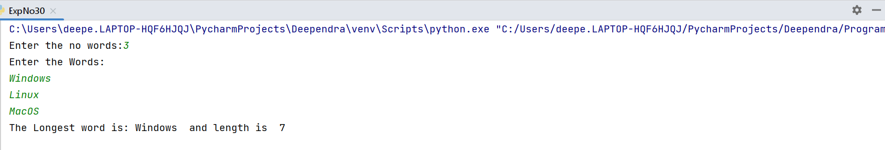**Output Screenshot**

**Result**

The program was executed and the result was successfully obtained. Thus CO1 was obtained.

**Experiment No.: 29**

**Aim**

Construct following pattern using nested loop

*

* *

* * *

* * * *

* * * * *

* * * *

* * *

* *

*

**CO2**

Implement decision making, looping constructs and functions

**Procedure**

n= int(input("Enter the length of pattern:"))  
for i in range(n):  
 for j in range(i):  
 print('*',end=" ")  
 print("")  
for i in range(n,0,-1):  
 for j in range(i):  
 print('*',end=" ")  
 print("")

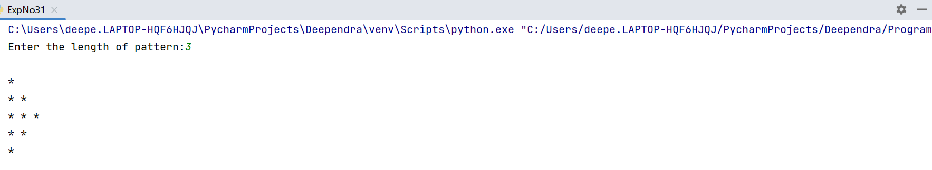**Output Screenshot**

**Result**

The program was executed and the result was successfully obtained. Thus CO1 was obtained.

**Experiment No.: 30**

**Aim**

Generate all factors of a number.

**CO2**

Implement decision making, looping constructs and functions

**Procedure**

def factor(num):  
 for i in range(1,num+1):  
 if num % i == 0:  
 print(i)  
num = int(input("Enter the number:"))  
factor(num)

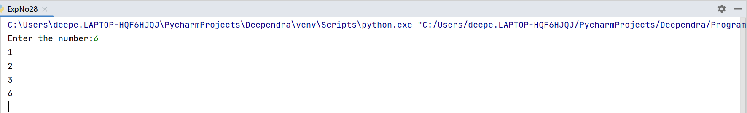**Output Screenshot**

**Result**

The program was executed and the result was successfully obtained. Thus CO1 was obtained.

**Experiment No.: 31**

**Aim**

Write lambda functions to find area of square, rectangle and triangle

**CO2**

Implement decision making, looping constructs and functions

**Procedure**

area_square = lambda x:x*x  
area_rectangle = lambda x,y: x*y  
area_triangle = lambda x,y: 1/2*x*y  
a=8  
b=4  
print("Area of square :",area_square(a))  
print("Area of rectangle:",area_rectangle(a,b))  
print("Area of triangle:",area_triangle(a,b))

**Output Screenshot**

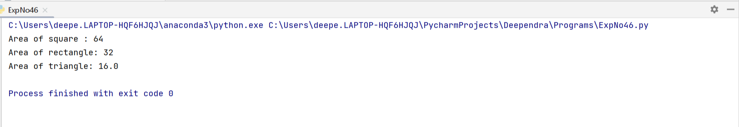

**Result**

The program was executed and the result was successfully obtained. Thus CO1 was obtained.

**Experiment No.: 32**

**Aim**

Work with built-in packages

**CO3**

Design modules and packages - built in and user defined packages

**Procedure**

**Output Screenshot**

**Result**

The program was executed and the result was successfully obtained. Thus CO1 was obtained.

**Experiment No.: 33**

**Aim**

Create a package graphics with modules rectangle, circle and sub-package 3D-graphics with

modules cuboid and sphere. Include methods to find area and perimeter of respective figures

in each module. Write programs that finds area and perimeter of figures by different importing

statements. (Include selective import of modules and import * statements)

**CO3**

Design modules and packages - built in and user defined packages

**Procedure**

**Circle.py**

def circleArea(r):  
 z=3.14*r*r  
 print("Area of circle:",z)  
  
def circlePerimeter(r):  
 y=2*3.14*r  
 print("Perimeter of circle:",y)

**Rectangle.py**

def rectangleArea(l,b):  
 x=l*b  
 print("Area of rectangle:",x)  
  
def rectanglePerimeter(l,b):  
 y=2*(l+b)  
 print("Perimeter of rectangle:",y)

**Cuboid.py**

def cuboidArea(l,w,h):  
 q=2*l*w+2*l*h+2*h*w  
 print("Area of cuboid:",q)  
  
def cuboidPerimeter(l,w,h):  
 w=4*(l+w+h)  
 print("Perimeter of cuboid:",w)

**Sphere.py**

def sphereArea(r):  
 t=4*3.14*r*r  
 print("Area of sphere:",t)  
  
def spherePerimeter(r):  
 u=4*3.14*r  
 print("Perimeter of sphere:",u)

**ExpNo33**

import Graphics.circle  
import Graphics.rectangle  
import Graphics.ThreeDGraphics.cuboid  
import Graphics.ThreeDGraphics.sphere  
  
Graphics.circle.circleArea(6)  
Graphics.circle.circlePerimeter(6)  
  
Graphics.rectangle.rectangleArea(10,5)  
Graphics.rectangle.rectanglePerimeter(10,5)

Graphics.ThreeDGraphics.cuboid.cuboidArea(3,6,6)  
Graphics.ThreeDGraphics.cuboid.cuboidPerimeter(3,6,6)  
  
Graphics.ThreeDGraphics.sphere.sphereArea(2)  
Graphics.ThreeDGraphics.sphere.spherePerimeter(2)

**Output Screenshot**

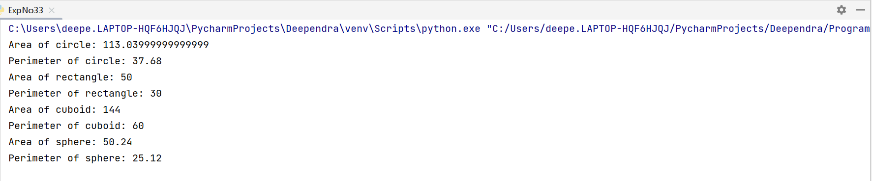

**Result**

The program was executed and the result was successfully obtained. Thus CO1 was obtained.

**Experiment No.: 34**

**Aim**

Create Rectangle class with attributes length and breadth and methods to find area and

perimeter. Compare two Rectangle objects by their area.

**CO4**

Implement object-oriented programming and exception handling.

**Procedure**

class Rectangle:  
 def __init__(self,length,breadth):  
 self.length=length  
 self.breadth=breadth  
  
 def area(self):  
 return self.breadth*self.length  
 def perimeter(self):  
 return 2*(self.length+self.breadth)  
  
l=int(input("Enter the length:"))  
b=int(input("Enter the breadth:"))  
o=Rectangle(l,b)  
x=o.area()  
y=o.perimeter()  
print("Area=",x)  
print("Perimeter=",y)  
  
l1=int(input("Enter the length:"))  
b1=int(input("Enter the breadth:"))  
p=Rectangle(l1,b1)  
x1=p.area()  
y1=p.perimeter()  
print("Area=",x1)  
print("Perimeter=",y1)  
  
if(x>x1):  
 print("First rectangle is greater than second rectangle")  
else:  
 print("Second rectangle is greater than first rectangle")

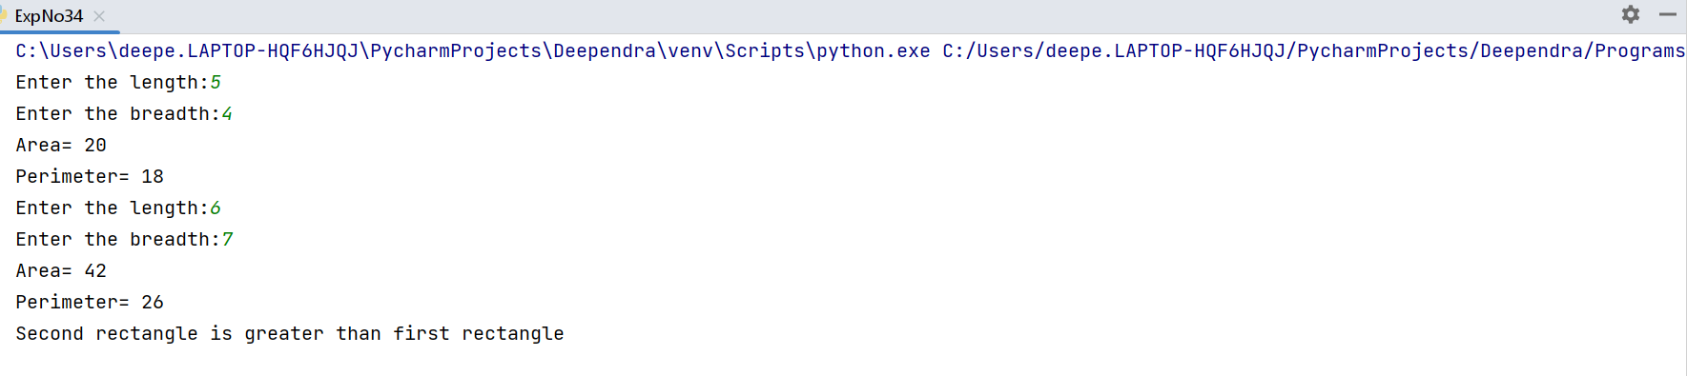**Output Screenshot**

**Result**

The program was executed and the result was successfully obtained. Thus CO1 was obtained.

**Experiment No.: 35**

**Aim**

Create a Bank account with members account number, name, type of account and balance.

Write constructor and methods to deposit at the bank and withdraw an amount from the bank.

**CO4**

Implement object-oriented programming and exception handling.

**Procedure**

class Bank:  
 def __init__(self,accno,name,accty):  
 self.accno=accno  
 self.name=name  
 self.accty=accty  
 self.bal=0  
 def showaccount(self):  
 print("Account holder name",self.name)  
 print("The Account no is", self.accno)  
 print("Account type",self.accty)  
 print("Account Balence",self.bal)  
  
 def deposit(self,d1):  
 self.bal=self.bal+d1  
 return self.bal  
 def withdraw(self,w1):  
 self.bal=self.bal-w1  
 return self.bal

b=int(input("Enter Your Account no:"))  
a=input("Enter Account name:")  
c=input("Enter Account type:")  
d=Bank(b,a,c)  
d.showaccount()  
while(True):  
 print("MENU")  
 print("\n 1.Deposit")  
 print("\n 2.Withdraw")  
 c=int(input("Enter choice:"))  
 f=0  
 if(c==1):  
 f=int(input("Enter the amount to deposit:"))  
 print("Your total bank deposit is\n ",d.deposit(f))  
  
 elif(c==2):  
 g=int(input("Enter the amount to withdraw:"))  
 if(g<f):  
 print("Insufficient balance")  
 else:  
 print("Total balance amount is:\n",d.withdraw(g))  
 else:  
 print("Enter valid choice")

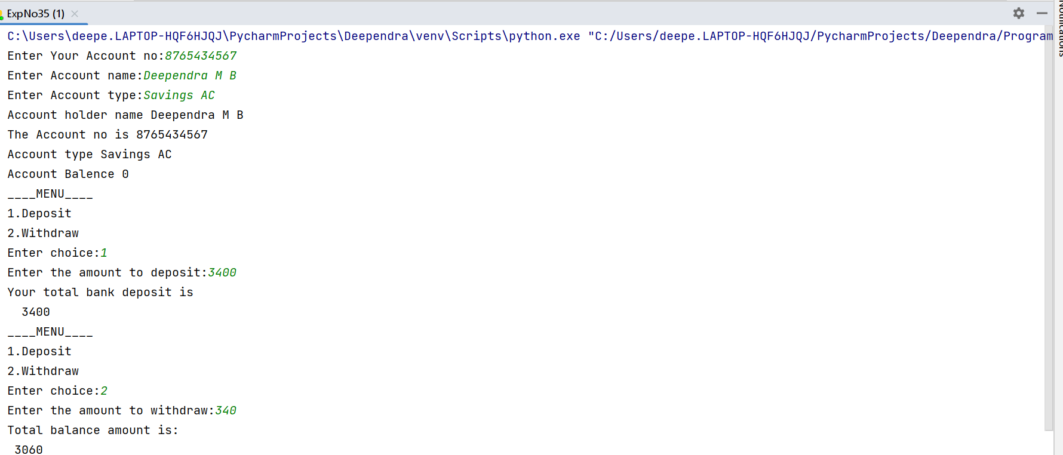**Output Screenshot**

**Result**

The program was executed and the result was successfully obtained. Thus CO1 was obtained.

**Experiment No.: 36**

**Aim**

Create a class Rectangle with private attributes length and width. Overload ‘<’ operator to

compare the area of 2 rectangles.

**CO4**

Implement object-oriented programming and exception handling.

**Procedure**

class Rectangle:  
 def __init__(self, length, width):  
 self.__length = length  
 self.__width = width  
  
 def area(self):  
 return self.__length * self.__width  
  
 def __lt__(self, other):  
 return self.area() < other.area()  
  
rect1 = Rectangle(4, 7)  
rect2 = Rectangle(4, 5)  
  
print("Area of rectangle 1 :",rect1.area())  
print("Area of rectangle 2 :",rect2.area())  
  
if rect1<rect2:  
 print("Area of rectangle 1 less than Rectangle 2")  
else:  
 print("Area of rectangle 2 is less than rectangle 1")

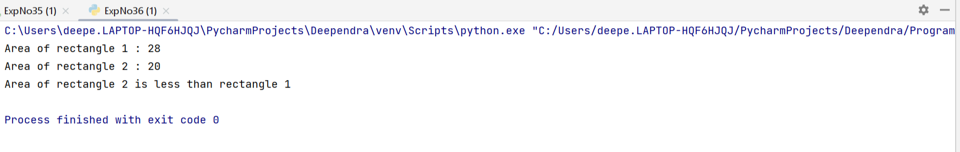**Output Screenshot**

**Result**

The program was executed and the result was successfully obtained. Thus CO1 was obtained.

**Experiment No.: 37**

**Aim**

Create a class Time with private attributes hour, minute and second. Overload ‘+’ operator to

find sum of 2 time.

**CO4**

Implement object-oriented programming and exception handling.

**Procedure**

class Time:  
 def __init__(self, hour, minute, second):  
 self.hour = hour  
 self.minute = minute  
 self.second = second  
  
 def __str__(self):  
 return f"{self.hour}:{self.minute}:{self.second}"  
  
 def __add__(self, other):  
 hour = self.hour + other.hour  
 minute = self.minute + other.minute  
 second = self.second + other.second  
  
 if second >= 60:  
 second -= 60  
 minute += 1  
  
 if minute >= 60:  
 minute -= 60  
 hour += 1  
  
 return Time(hour, minute, second)  
  
time1 = Time(1, 20, 30)  
time2 = Time(2, 45, 15)  
  
print(time1)  
print(time2)  
print(time1 + time2)

**Output Screenshot**

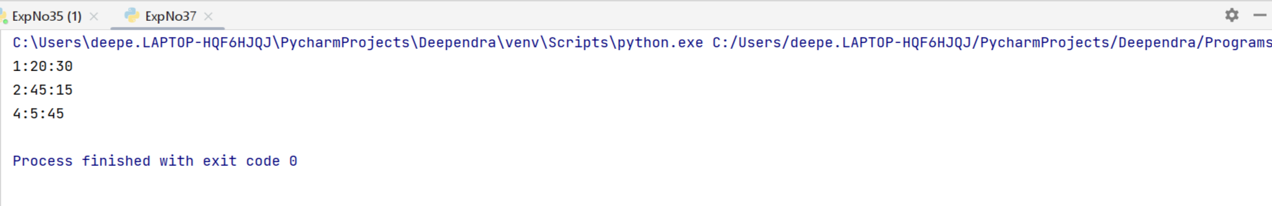

**Result**

The program was executed and the result was successfully obtained. Thus CO1 was obtained.

**Experiment No.: 38**

**Aim**

Create a class Publisher (name). Derive class Book from Publisher with attributes title and

author. Derive class Python from Book with attributes price and no_of_pages. Write a

program that displays information about a Python book. Use base class constructor invocation and method overriding.

**CO4**

Implement object-oriented programming and exception handling.

**Procedure**

class Publisher:  
 def getpublisher(self):  
 self.name=input("Enter the name of the publisher:")  
  
 def display(self):  
 print("Name of the publisher:",self.name)  
  
class Book(Publisher):  
 def getbook(self):  
 self.title=input("Enter the title of the book:")  
 self.author=input("Enter the name of the author:")  
  
 def display1(self):  
 print("Title:",self.title)  
 print("Author:",self.author)  
  
class Python(Book):  
 def bookdetails(self):

self.price=int(input("Enter the price:"))  
 self.pages=int(input("Enter number of pages:"))  
  
 def display2(self):  
  
 print("Price:",self.price)  
 print("Pages:",self.pages)  
  
  
obj1=Python()  
obj1.getpublisher()  
obj1.getbook()  
obj1.bookdetails()  
obj1.display()  
obj1.display1()  
obj1.display2()

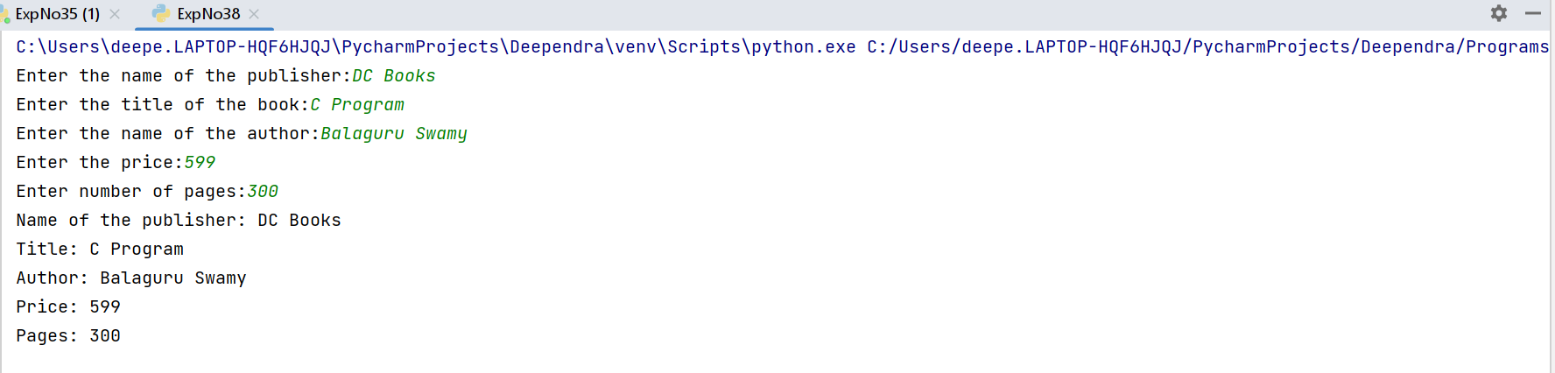**Output Screenshot**

**Result**

The program was executed and the result was successfully obtained. Thus CO1 was obtained.

**Experiment No.: 39**

**Aim**

Write a Python program to read a file line by line and store it into a list.

**CO5**

Create files and form regular expressions for effective search operations on strings and

files.

**Procedure**

f=open("demo.txt","r")

list=f.readlines()

print("The content of the file is :",list)

f.close()

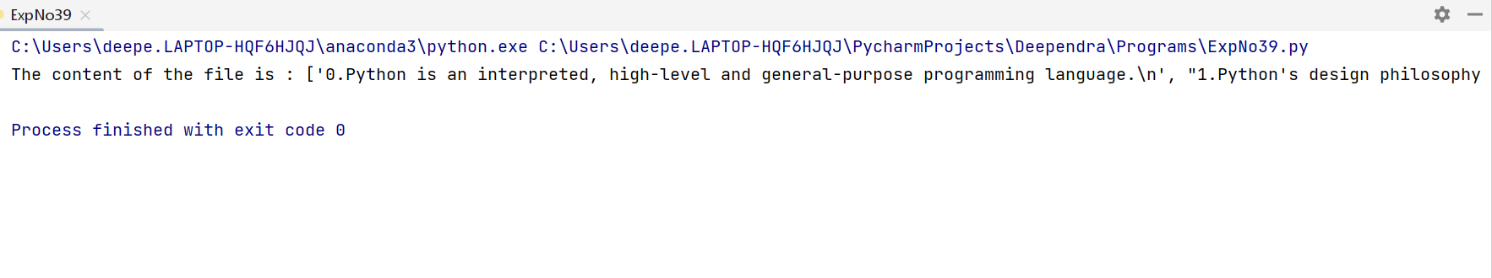**Output Screenshot**

**Result**

The program was executed and the result was successfully obtained. Thus CO1 was obtained.

**Experiment No.: 40**

**Aim**

Python program to copy odd lines of one file to other

**CO5**

Create files and form regular expressions for effective search operations on strings and

files.

**Procedure**

f=open("demo.txt","r")

f1=open("odd.txt","w")

content=f.readlines()

for i in range(0,len(content)):

if(i%2!=0):

f1.write(content[i])

else:

pass

f.close()

f1.close()

f=open("odd.txt","r")

c=f.read()

print(c)

f.close()

**Output Screenshot**

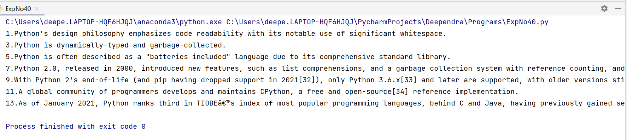

**Result**

The program was executed and the result was successfully obtained. Thus CO1 was obtained.

**Experiment No.: 41**

**Aim**

Write a Python program to read each row from a given csv file and print a list of strings.

**CO5**

Create files and form regular expressions for effective search operations on strings and

files.

**Procedure**

import csv

with open("dep.csv","r")as f:

r=csv.reader(f)

for i in r:

print(i)

**Output Screenshot**

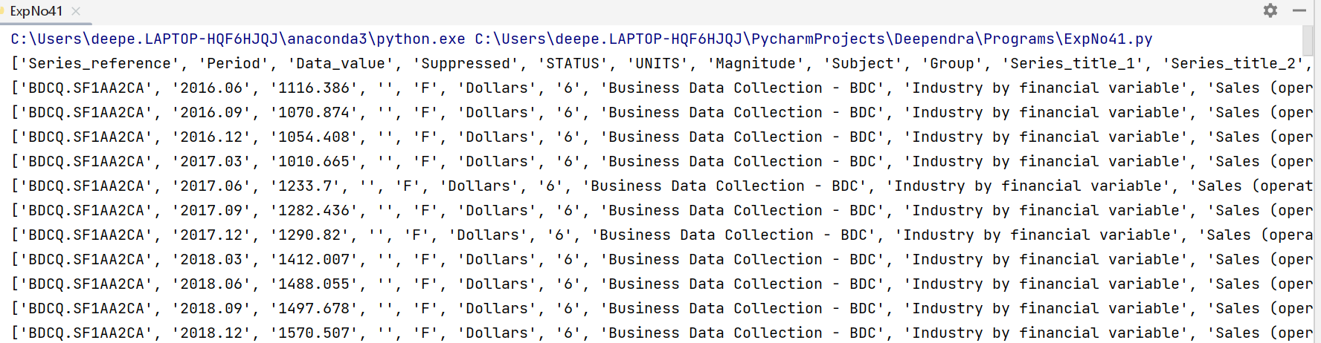

**Result**

The program was executed and the result was successfully obtained. Thus CO1 was obtained.

**Experiment No.: 42**

**Aim**

Write a Python program to read specific columns of a given CSV file and print the content

of the columns.

**CO5**

Create files and form regular expressions for effective search operations on strings and

files.

**Procedure**

import csv

with open("dep.csv",newline='')as f:

d=csv.DictReader(f)

print("Magnitude Subject")

print("________________________")

for i in d:

print(i['Magnitude'],i['Subject'])

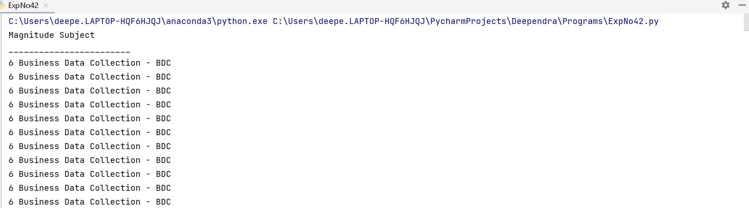**Output Screenshot**

**Result**

The program was executed and the result was successfully obtained. Thus CO1 was obtained.

**Experiment No.: 43**

**Aim**

Write a Python program to write a Python dictionary to a csv file. After writing the CSV file

read the CSV file and display the content.

**CO5**

Create files and form regular expressions for effective search operations on strings and

files.

**Procedure**

import csv

c_col=['ID','Name','Age']

dict_data=[{'ID':1,'Name':'Raoof','Age':15},

{'ID':2,'Name':'Abina','Age':17},

{'ID':3,'Name':'Aleena','Age':18},

{'ID':4,'Name':'Anjaly','Age':19},

{'ID':5,'Name':'Alan','Age':20},

{'ID':6,'Name':'Amin','Age':41},

{'ID':7,'Name':'Fathima','Age':22},

{'ID':8,'Name':'Alex','Age':30},

{'ID':9,'Name':'Arya','Age':40},

{'ID':10,'Name':'Alfiya','Age':14}]

try:

with open("name.csv","w")as f:

write=csv.DictWriter(f,fieldnames=c_col)

write.writeheader()

for i in dict_data:

write.writerow(i)

except IOError:

print("Input/Output Error")

d=csv.DictReader(open("name.csv"))

print('CSV File output is : ')

for i in d:

print(i)

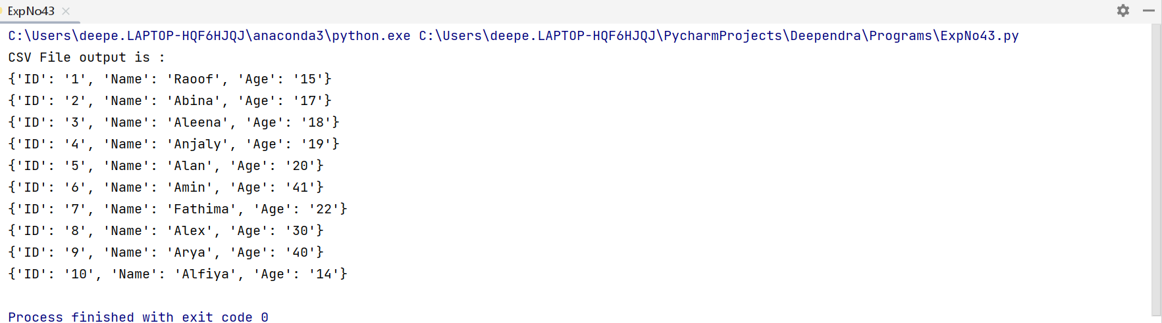**Output Screenshot**

**Result**

The program was executed and the result was successfully obtained. Thus CO1 was obtained.

**Experiment No.: 44**

**Aim**

Write a python program to read a CSV file and write the first and display the result in

List format

**CO5**

Create files and form regular expressions for effective search operations on strings and

files.

**Procedure**

import csv  
with open('dep.csv', 'r') as original_file:  
 reader = csv.reader(original_file)  
  
 with open('new.csv', 'w', newline='') as new_file:  
 writer = csv.writer(new_file)  
  
 for i in range(5):  
 writer.writerow(next(reader))  
  
 with open('new.csv', 'r') as new_file:  
 reader = csv.reader(new_file)  
 for row in reader:  
 print(row)

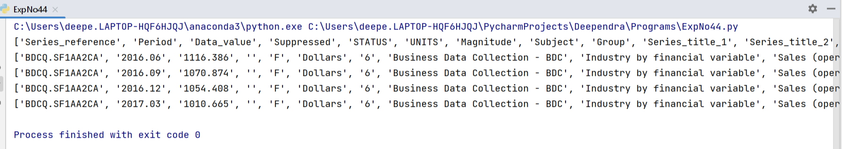**Output Screenshot**

**Result**

The program was executed and the result was successfully obtained. Thus CO1 was obtained.

**Experiment No.: 45**

**Aim**

Write a python program to read a CSV file and write the odd rows to a new file and even rows another new file and finally display both.

**CO5**

Create files and form regular expressions for effective search operations on strings and

files.

**Procedure**

import csv  
  
with open('dep.csv', 'r') as original_file:  
 reader = csv.reader(original_file)  
  
  
 with open('odd.csv', 'w', newline='') as odd_file:  
 odd_writer = csv.writer(odd_file)  
  
  
 with open('even.csv', 'w', newline='') as even_file:  
 even_writer = csv.writer(even_file)  
  
  
 i = 1  
 for row in reader:  
 if i % 2 == 1:  
 odd_writer.writerow(row)  
 else:  
 even_writer.writerow(row)  
 i += 1  
  
 with open('odd.csv', 'r') as odd_file:  
 reader = csv.reader(odd_file)  
  
 print("Odd rows:")  
 for row in reader:  
 print(row)

with open('even.csv', 'r') as even_file:  
 reader = csv.reader(even_file)  
  
 print("Even rows:")  
 for row in reader:  
 print(row)

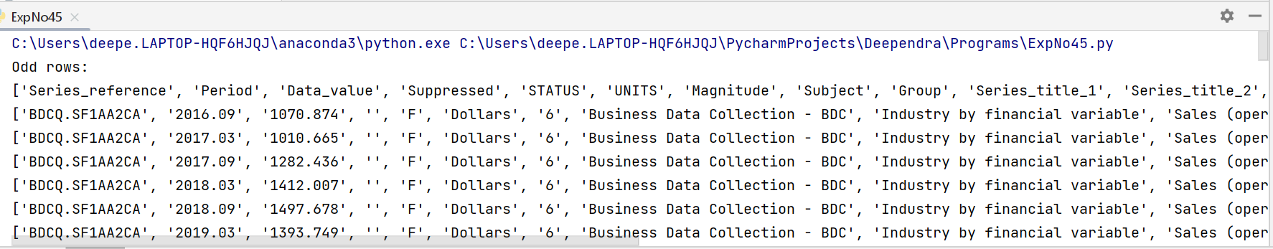**Output Screenshot**

**Result**

The program was executed and the result was successfully obtained. Thus CO1 was obtained.

**Experiment No.: 0**

**Aim**

**CO**

**Procedure**

**Output Screenshot**

**Result**

The program was executed and the result was successfully obtained. Thus CO1 was obtained.